**2. ReactJS-HOL**

1. Create a React App

|  |
| --- |
| npx create-react-app studentapp |

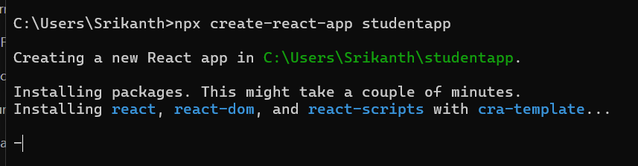

2.Create a Components Folder

3. Create Home.js in Component Folder

|  |
| --- |
| Home.js  import React, { Component } from 'react';  class Home extends Component {    constructor() {      super();      this.state = {};    }    render() {      return (        <div>          <h2>Welcome to the Home page of Student Management Portal</h2>        </div>      );    }  }  export default Home; |

4. Create About.js in Component Folder

|  |
| --- |
| About.js  import React from 'react';  function About() {    return (      <div>        <h2>Welcome to the About page of the Student Management Portal</h2>      </div>    );  }  export default About; |

5. Create Contact.js in Component Folder

|  |
| --- |
| Contact.js  import React from 'react';  function Contact() {    return (      <div>        <h2>Welcome to the Contact page of the Student Management Portal</h2>      </div>    );  }  export default Contact; |

6. Modify App.js

|  |
| --- |
| App.js  import React from 'react';  import './App.css';  import Home from './Components/Home';  import About from './Components/About';  import Contact from './Components/Contact';  function App() {    return (      <div className="App">        <Home />        <About />        <Contact />      </div>    );  }  export default App; |

7. Run the app

|  |
| --- |
| npm start |

**OUTPUT:**

